**Classical conditioning of insulin effects in patients with diabetes type-2 and healthy controls.**

Aleksandrina Skvortsova1,2, Dieuwke S. Veldhuijzen2, Lotte F. van Dillen3, Hilmar Zech4, Suzanne M.J.C. Derksen2, Ruben Sars5, Onno C Meijer6, Hanno Pijl7, Andrea WM Evers2,8,9

1. Department of Psychology, McGill University, Canada; 2. Health, Medical and Neuropsychology unit, Faculty of Social and Behavioural Sciences, Leiden University, the Netherlands; 3. Social, Economic and Organizational Psychology unit, Faculty of Social and Behavioural Sciences, Leiden University, the Netherlands; 4. Neuroimaging center, Dresden University of Technology, Germany; 5. Department of Family Medicine, Maastricht University, the Netherlands; 6. Department of Medicine, Division of Endocrinology, Leiden University Medical Centre, Leiden, the Netherlands; 7. Department of Internal Medicine, Division of Endocrinology and Metabolic Diseases, Leiden University Medical Center, Leiden, the Netherlands; 8. Department of Psychiatry, Leiden University Medical Center, Leiden, the Netherlands; 9. Medical Delta, Leiden University, Technical University Delft and Erasmus University, the Netherlands.

**Abstract**

**Aims/hypothesis.** Pharmacological conditioning were an association is formed between a drug and a conditioned stimulus (CS, e.g., smell) can influence physiological processes. Evidence exists that it is possible to condition insulin effects in both animals and healthy humans but it is unclear whether this can be done in patients as well. The aim of this study was to investigate the effects of conditioning with intranasal insulin on blood glucose, insulin, c-peptide, hunger and memory in patients with diabetes type-2 and age- and sex-matched healthy controls. Exploratively, we examined sex differences in these effects and the differences between patients and healthy controls. We hypothesized that conditioning with insulin would trigger endogenous insulin release, decrease blood glucose and hunger and improve memory.

**Methods.** In a randomized double-blind controlled trial, thirty-two patients with diabetes type-2 (17 males, mean age=68.8, SD=11.86) and thirty-two healthy controls (17 males, mean age=67.8, SD=6.12) were randomly assigned to a conditioned or a control group. On day 1, participants in the conditioned group received 6 administrations of 20 units of intranasal insulin together with a CS (smell of rosewood oil) while the control group received a placebo with the CS. On day 2, participants in both groups received a placebo spray with the CS. Glucose, insulin and c-peptide were measured in blood throughout the days. Hunger was measured with a self-report question, a mobile approach-avoidance task and a bogus taste test. Memory was measured with an auditory verbal learning test.

**Results.** Intranasal insulin prevented the drop of glucose levels in patients but not in healthy controls (B=0.03, SE=0.02, p=. 027), and decreased C-peptide levels in healthy controls and not patients (B=0.01, SE=0.001, p=0.008). Conditioning with insulin also prevented the drop of blood glucose levels but only in male participants (both healthy and patients) (B=0.001, SE=0.0003, p=0.024). Moreover, conditioning significantly decreased hunger in healthy participants (B=0.31, SE=0.09, p< 0.001). No effects of intranasal insulin or conditioning were found on insulin, approach-avoidance tendencies, calories eaten and memory.

**Conclusions/interpretation.** Our study provides further evidence that conditioning with intranasal insulin might modify blood glucose levels and decrease hunger, but its effects differ depending on the health status and sex. The unexpected direction of the effects of intranasal insulin on blood glucose might be due to the age as our study population was older than participants from previous research. Conditioning with intranasal insulin might be beneficial for the groups suffering from intensive hunger, but might not be particularly suitable for blood glucose reduction. To be able to apply conditioning to clinical practice, it is important to better understand the action of the drug chosen as an unconditioned stimulus as well as the impact of sex and age.

**Trial registration.** The trial was registered in the Netherlands Trial Register under a number NL7783 (<https://www.trialregister.nl/trial/7783>).

**Funding.** ZonMW and Diabetes Fonds, Diabetes II Breakthrough project (number 459001009).

**Introduction**

Accumulating evidence suggests that it is possible to modulate endocrine functions using classical conditioning [1, 2]. Such conditioned effects are usually induced by pharmacological conditioning: coupling of an active medication (unconditioned stimulus, US) with an initially neutral stimulus (conditioned stimulus, CS). In case of endocrine conditioning, hormonal-stimulating or inhibiting medication (US) gets associated with a CS, and later the mere presentation of the CS alone leads to changes in hormone levels or effects associated with this hormone.

The most convincing evidence on endocrine conditioning comes from studies on the conditioning of insulin and glucose responses in animals and healthy humans [3–6]. Insulin and glucose responses seem to be particularly malleable by the mechanisms of classical conditioning [2], probably due to their important acute homeostatic functions aimed at maintaining metabolism. Experimental studies demonstrated that coupling of food with any neutral stimuli, such as sound or light, can trigger conditioned insulin release [7–9]. Moreover, insulin and glucose responses can be conditioned using other than food unconditioned stimuli. Using insulin injections as an US, it was found possible to classically condition glucose decrease in healthy young volunteers [6, 10]. Another study successfully conditioned insulin release and glucose decrease in healthy volunteers using intranasal insulin administration as a US [5].

Up to date, all insulin conditioning studies have been performed either in animals or in healthy young human volunteers and there are no reports of the possibility to condition insulin responses in groups with metabolic disorders. Particularly, patients with diabetes type-2 might benefit from conditioning with intranasal insulin as an unconditioned stimulus as intranasal insulin has been shown to have a number of benefits for patients with diabetes type-2. Conditioning with insulin might trigger conditioned insulin release and glucose decrease [5] without causing common side effects of intravenous insulin injections such as hypoglycaemia and hypertension [11]. Moreover, since intranasal insulin normalizes hypothalamic neuronal activity in response to glucose ingestion, it could be especially favorable for type-2 diabetes patients who demonstrate distorted brain responses to glucose [12, 13]. Additionally, evidence suggests that intranasal insulin decreases food intake and hunger [14, 15], and improves memory both in healthy volunteers and patients with diabetes type-2 [16, 17]. Taken together, classical conditioning with intranasal insulin has a wide range of potential positive effects for patients with diabetes type-2.

The aim of the present study was to investigate the effects of conditioning with intranasal insulin on blood glucose, insulin, C-peptide, hunger and memory in a group of diabetes type-2 patients and age and sex-matched healthy controls. Additionally, we aimed to explore differences between healthy individuals and patients with diabetes type-2 and possible sex differences in the effects of conditioning with intranasal insulin.

**Methods**

**Participants**

Patients diagnosed with diabetes type-2 and healthy controls were included in the study. Healthy controls were matched for age (the mean age of the groups was matched +/-1 year) and sex to the patients group. Inclusion criteria for the patients were: 1) being older than 18 years old; 2) current diagnosis of diabetes type-2; 3) taking metformin and/or participating in a lifestyle intervention (e.g., diet) to control their diabetes. The details about patient inclusion, exclusion criteria and sample size calculation are presented in the ESM.

**Study design**

The study had a double-blind randomized placebo-controlled design. Thirty-two patients with diabetes type-2 and thirty-two healthy controls were randomized to one of two groups in a double-blind manner: 1) conditioned group; 2) control group. This study was an adaptation of the study design used by Stockhorst and colleagues [5] for conditioning insulin responses in healthy participants. The study conditions are presented in Figure 1.

The study was approved by the Medical Ethical Committee of Leiden, Den Haag, Delft under a protocol number P18.222.

**Figure 1.** Study design.

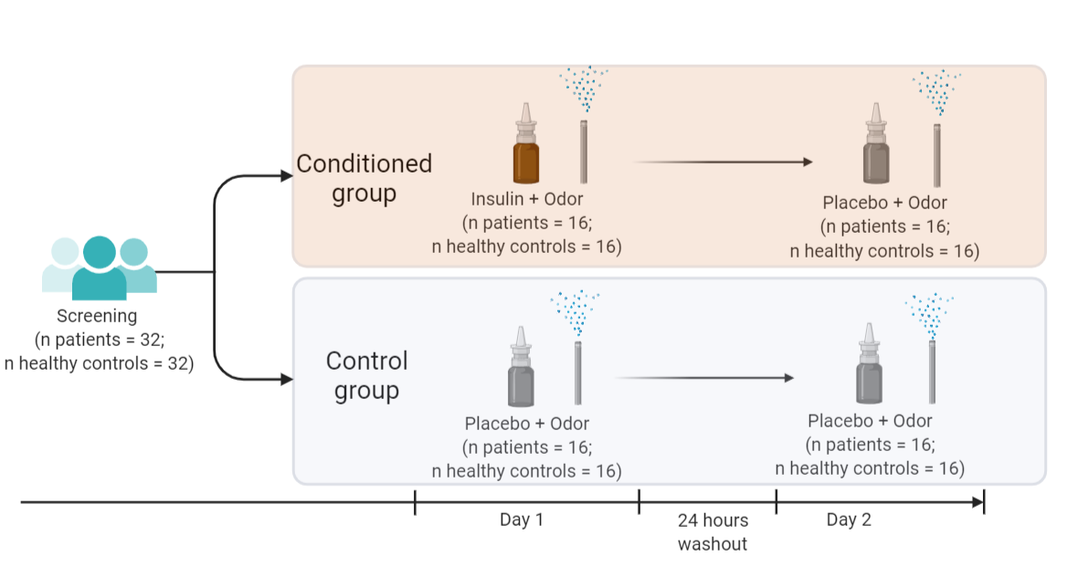

**Procedure**

Candidates, who expressed their interest to participate in the study, were first contacted by phone for an initial 10-minute screening. During the screening, inclusion criteria were checked and participants were provided with study details. Participants were informed that the study aimed to investigate the effects of intranasal insulin on several blood measures, hunger and memory. They remained unaware of the specific conditioning hypothesis.

Eligible participants were invited to the laboratory of the Clinical Research Unit of the Leiden University Medical Center for two visits. They were asked to refrain from eating, drinking alcohol and caffeinated drinks and exercising minimum 12 hours before the study. Patients, who received metformin as a treatment, were asked not to take it the morning of the study but they were allowed to take it immediately after the end of the session.

On day 1, upon arrival to the lab, participants signed an informed consent form. Their weight and height were measured and their health status and medication use were assessed. After that, an intravenous catheter was inserted into the median cubital vein. A baseline blood draw was done immediately after that. Subsequently, participants were asked to smell a smelling pen for one minute by holding the pen approximately 1 cm away from their nose. Immediately thereafter, participants in the conditioned group received 20 units of intranasal insulin spray into one nostril with one puff. Participants in the control group received a placebo spray. Right after administration of the spray, participants were asked to smell the smelling pen for one more minute. Afterwards, another sample of blood was drawn. After the blood draw, participants were asked to rate how well they could smell the odor, and their hunger was measured. This procedure of smell-spray-smell administration followed by blood draw and hunger rating was repeated 6 times every 15 minutes. In between, participants could read a newspaper. After the last spray, participants were given the first part of the memory task. 15 minutes after the last spray, the last blood sample was drawn and the catheter was removed. Subsequently, the second part of the memory task was done followed by a mobile food Approach Avoidance Task and a bogus taste test. Day 2 was identical to day 1, however, participants in both conditioned and control groups, received a placebo nasal spray. At the end of the day 2, participants were fully debriefed about the aims of the study and received a reward of 100 euros.

**Figure 2**. Study procedures.

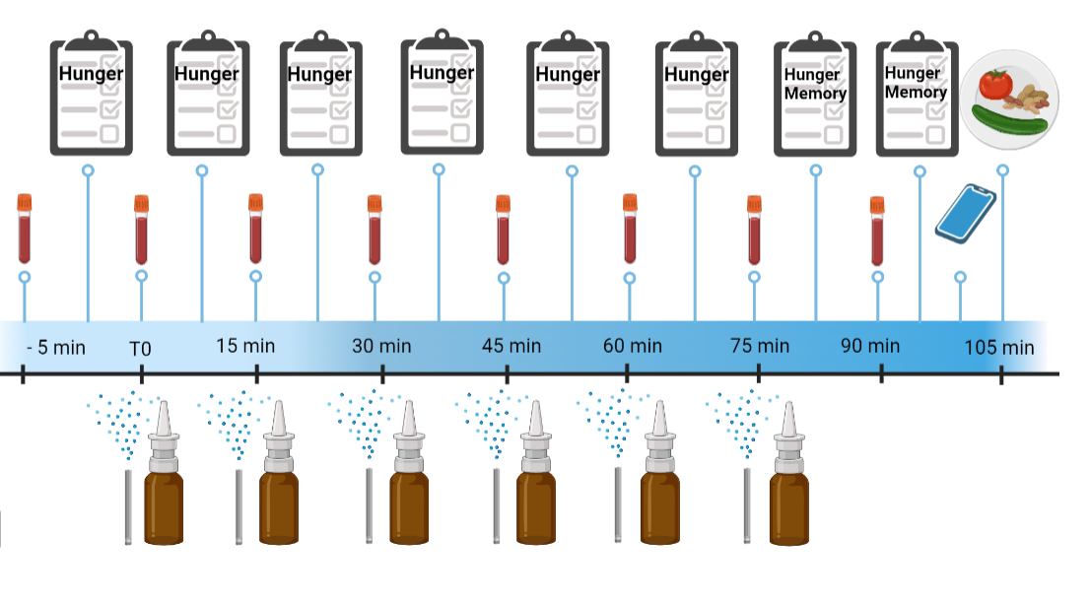

**Materials**

***Unconditioned stimulus***

The unconditioned stimulus was 20 units (0.2 ml) of fast-acting insulin (Insulin NovoRapid; Novo Nordisk), administered six time on day 1 in the conditioned group. Placebo nasal spray was used in the control group on day 1 and on day 2 in both groups.

***Conditioned stimulus***

Commercially available felt-tip pens were filled with rosewood oil used as a CS. During the smell presentation, participants were asked to hold the pen on a distance of approximately 1 cm in front of both nostrils for one minute before and one minute after the nose spray administration.

The details about the unconditioned and conditioned stimuli are presented in the **ESM**.

**Measurements**

The details of all measurements are presented in the **ESM** (Electronic Supplementary Material).

***Primary outcomes***

*Glucose, insulin, and c-peptide* levels were measured in blood at baseline, after each spray administration and 15 min after the last spray.

*Hunger* was measured with a self-rated question “How hungry do you feel at the moment” at the beginning of each session, 5 minutes after each spray administration and 20 minutes after the last spray administration.

***Secondary outcomes***

*Approach tendencies towards food* were measured with a validated mobile phone approach avoidance task in which participants were presented pictures of food and non-food objects [18]. The task consisted of two blocks: In one block, participants were asked approach foods by pulling them towards themselves and to avoid objects by pushing them away. In the other block, they were asked to do the opposite—to avoid foods and to approach objects. During each movement reaction times and response forces were measured. Food approach tendencies are calculated by comparing how fast/strong participants approach foods compared to avoiding them..

*Food consumption* was measured with a bogus taste test adapted from previous studies [19, 20]. At the end of day 1 and 2, participants were offered several snacks: nuts, cucumbers, blueberries, tomatoes, red pepper and carrots. They were allowed to eat as much as they wanted to. Afterwards, the weight of the eaten snacks was measured and the total number of calories eaten was calculated. This task was used to measure the food consumption in previous research [20].

*Memory* was assessed by the auditory verbal learning test in which 15 words were read to participants 5 times and participants were asked to repeat all the words they could remember after each reading. Fifteen minutes after the first assessment participants were asked to name the words, they still were able to recall. This is a reliable test for measuring learning and memory [21].

**Statistical analysis**

The data analyses were performed using SPSS Statistics version 21 (IBM Corporation, Armonk, NY) and RStudio (version 1.1.447; R version 4.0.4). The data and the code are made available on… All analyses were performed with a 2-tailed significance level of α <.05.

A 2 condition (conditioned vs control) x 2 group (healthy vs patient) multivariate analysis of variance was used to compare the groups on the baseline characteristics: age, body mass index, baseline glucose, insulin and c-peptide values and baseline hunger.

The lmer function of the nlme package in R (R Core Team, 2013) was used for the liner mixed effects models analyses. Mixed effects models were applied to the data that included repeated measures (glucose, insulin, C-peptide, hunger and approach-avoidance task). In all models, the intercept was allowed to vary randomly across participants. The details of the models and the assumptions check are presented in **ESM**.

To examine the effects of intranasal insulin administration on blood glucose levels on day 1, a mixed model was performed with day 1 glucose levels as a dependent variable, condition (conditioned vs control), group (healthy vs patient), measurement time (0, 15, 30, 45, 60, 75 or 90 minutes after the first spray administration), baseline glucose levels (measured before the first spray administration) and an interaction between these variables as predictors. To examine the effects of conditioning on blood glucose levels, the same mixed model analysis was performed but with the measures of the day 2. The same analyses were run with insulin, C-peptide and hunger for each day separately to investigate whether intranasal insulin and conditioning affected these measures. In case an interaction factor was significant, separate models were run for either two groups (healthy and patients) or conditions (conditioned and control) depending on which of the factors was included in this interaction. All mixed models were repeated with sex as a predictor in an exploratory analysis to investigate whether sex affected the relationships between the variables.

To examine whether intranasal insulin and conditioning affected the approach tendencies towards food, two mixed models were performed. The first model included condition (conditioned vs control), groups (patient vs healthy), day (1 vs 2), stimulus time (food versus object), movement type (pull versus push) and interaction between these factors as predictors and reaction time as a dependent variable. The second model included the same predictors but movement force as a dependent variable.

A 2 condition (conditioned vs control) x 2 group (healthy vs patient) factorial analysis of variance (ANOVA) was used to compare the groups on the food consumption during the bogus test: one analysis was run for day 1 another one for day 2 separately with calories eaten as an outcome measure. A 2 condition (conditioned vs control) x 2 group (healthy vs patient) factorial ANOVA was used to compare the groups on their memory scores (immediate recall, learning, percentage forgetting). As three separate memory outcomes were used in the analysis, Bonferroni corrections were applied and alpha level was set to 0.016.

**Results**

**Participants**

Thirty-two patients with diabetes type-2 (17 males, mean age=68.3, SD=11.86) and thirty-two healthy volunteers (17 males, mean age=67.8, SD=6.12) were included in the study. The flowchart with the numbers of screened participants and dropouts is presented in the Figure 3.

The means and SEs of the baseline characteristics are presented in Table 1. There was no difference between conditions (conditioned group versus control) in any baseline characteristics (F(10,50)=0.93, p=0.517, Wilk's Λ=0.84). Patients and healthy controls differed on a number of baseline characteristics (F(10,50)=15.24, p< .001, Wilk's Λ=.25). Patients had a higher BMI (F(1,63)=14.86, p< .001), higher baseline levels of glucose (F(1,63)=114.32, p< .001) and c-peptide (F(1,63)=9.87, p< .01) on day 1, higher glucose levels (F(1,63)=91.72, p< .001) and c-peptide (F(1,63)=4.95, p=.03) on day 2 and higher hunger at baseline on day 1 (F(1,63)=14.61, p< .001) than healthy controls.

**Table 1**. Baseline characteristics with standard errors across groups and study conditions.

|  |  |  |  |  |
| --- | --- | --- | --- | --- |
|  | Conditioned group | | Control group | |
|  | Patients | Healthy controls | Patients | Healthy controls |
| Age | 68.31 (2.37) | 67.69 (2.37) | 68.20 (2.44) | 67.81(5.5) |
| Body mass index | 29.77 (0.84) | 25.08 (0.84) | 27.77 (0.87) | 25.92 (0.84) |
| Baseline insulin, day 1 | 14.59 (2.17) | 9.01 (2.17) | 12.69 (2.17) | 12.07 (2.17) |
| Baseline glucose, day 1 | 8.49 (0.28) | 5.35 (0.28) | 8.36 (0.28) | 5.43 (0.28) |
| Baseline c-peptide, day 1 | 1.12 (0.10) | 0.74 (0.10) | 1.14 (0.10) | 0.90 (0.10) |
| Baseline hunger, day 1 | 4.5 (0.64) | 2.09 (0.64) | 5.2 (0.66) | 2.69 (0.64) |
| Baseline insulin, day 2 | 12.8 (2.10) | 9.42 (2.10) | 10.67 (2.17) | 13.11 (2.10) |
| Baseline glucose, day 2 | 8.34 (0.30) | 5.28 (0.30) | 8.18 (0.31) | 5.41 (0.30) |
| Baseline c-peptide, day 2 | 1.08 (0.10) | 0.77 (0.10) | 1.07 (0.10) | 0.94 (0.10) |
| Baseline hunger, day 2 | 3.91 (0.60) | 2.59 (0.60) | 4.73 (0.62) | 4.19 (0.60) |

**Figure 3.** Flowchart with total number of participants at each step of the trial.

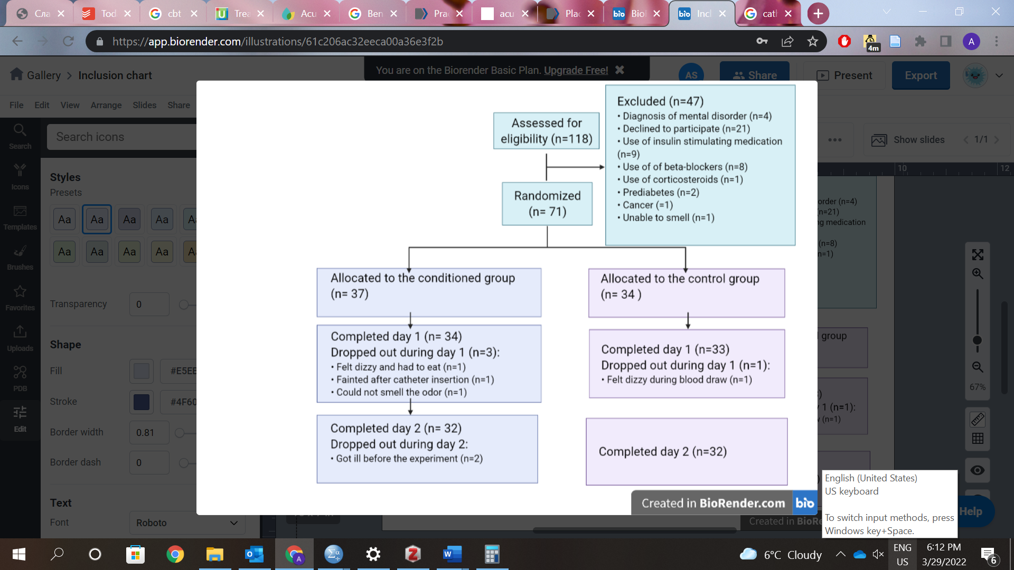

**Blood glucose**

*Effects of insulin spray (Day 1).* The effect of time- group- condition interaction (B=0.03, SE=0.02, p=0. 027) on the blood glucose levels on Day 1 was significant. Glucose levels were significantly decreasing with time in healthy participants in both conditioned and control conditions (B=-0.02, SE=0.01, p=0. 002). In patients, there was a significant time-condition interaction (B=0.03, SE=0.01, p=.011), indicating a significant decrease in glucose levels in patients who received a placebo spray while this decrease was absent in patients who received insulin.

When sex was added to the model as a predictor, a significant time-condition-group-sex interaction was found (B=0.05, SE=0.02, p=0.025). There was a significant time-condition-group interaction in male participants (B=0.046, SE=0.02, p=0.021), indicating that there was a significant decrease in blood glucose levels in males who received placebo, while males who received insulin had stable glucose levels (Figure 4). The effect of condition (B=0.01, SE=0.12, p=0.917) and interactions between condition and other predictors (all p’s > 0.54) were insignificant in females.

*Effects of conditioning (Day 2).* The effect of group-time interaction (B=-0.005, SE=0.001, p=0.003) on glucose on Day 2 was significant, indicating that there was a decrease in blood glucose levels in both healthy participants (B=-0.003, SE=0.001, p=0.008) and patients (B=-0.01, SE=0.001, p< 0.001), however, this decrease was more pronounced in patients (Figure 4). Condition (conditioned vs control) did not affect glucose levels on day 2 (B=-0.0004, SE=0.02, p=0.976).

When sex was added to the model as a predictor, a significant effect of a time-sex-condition interaction (B=0.001, SE=0.0003, p=0.024) was found. There was a significant effect of time-condition interaction in male (B=-0.02, SE=0.01, p=0.024) but not female participants (B=-0.001, SE=0.03, p=0.98), indicating that control males had a decrease in blood glucose level, that was absent in conditioned males.

**Figure 4.** The mean changes of glucose levels from baseline with standard errors.

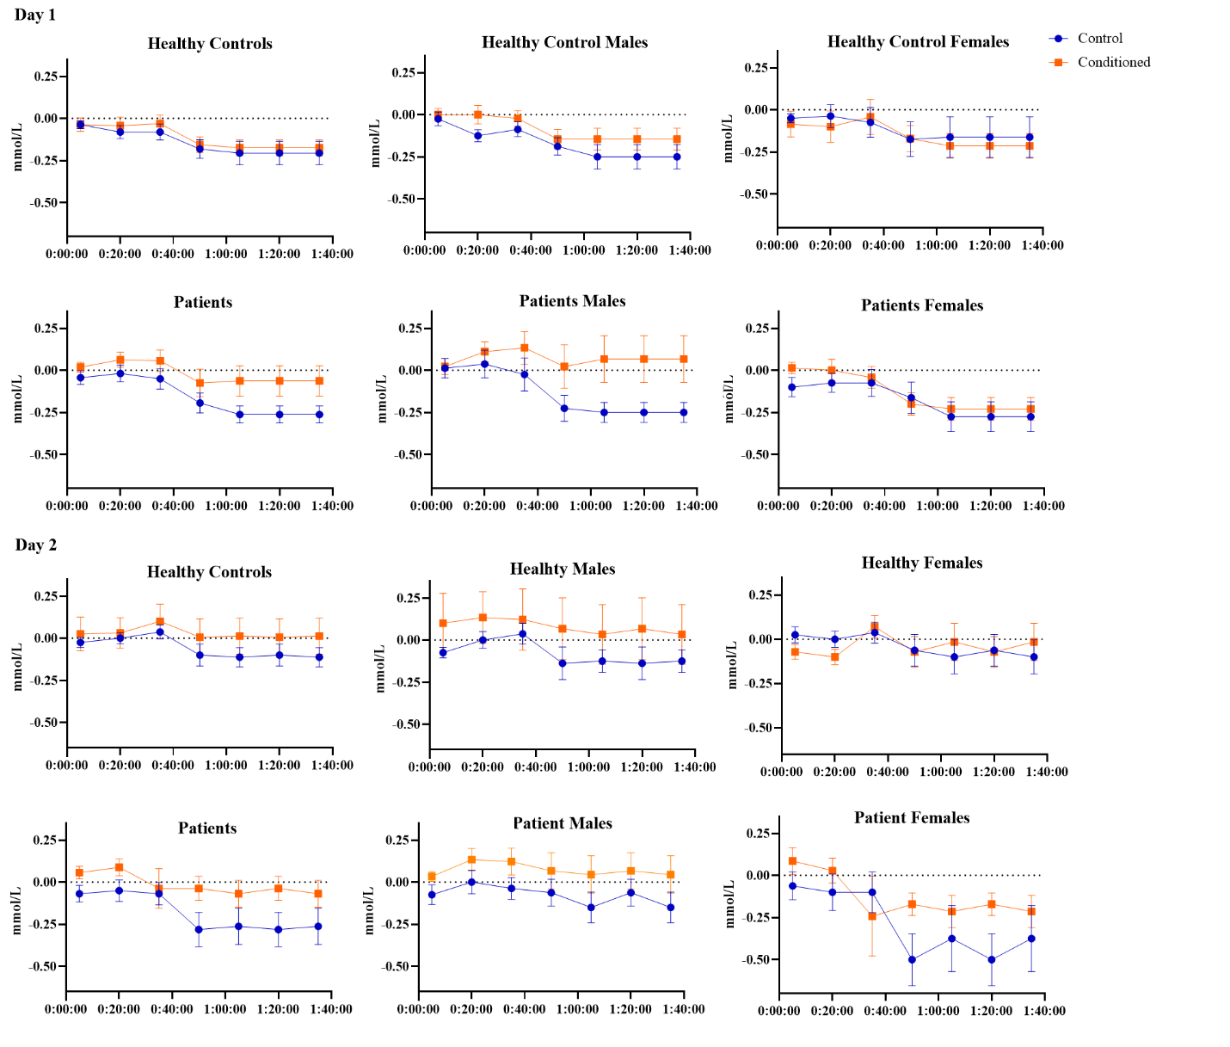

**Insulin**

*Effects of insulin spray (Day 1).* There was no effect of condition (insulin versus placebo spray) (B=-0.07, SE=0.15, p=0.671), group (B=0.14, SE=0.15, p=0.361) or time (B=-0.02, SE=0.01, t(380)=-1.69, p=0.092) on the insulin levels on day 1, neither was the interaction between these factors significant (B=0.05, SE=0.03, p=0.084) (Figure 5).

There was no significant effect of sex on the insulin levels on day 1 (B=-0.01, SE=0.21, p=0.98), also the interactions of other variables with sex were not significant (all p’s >.14).

*Effects of conditioning with insulin (Day 2)*. There was no effect of condition (conditioned versus control) (B=0.02, SE=0.09, p=0.83) or time (B=0.02, SE=0.09, p=0.829) on the insulin levels on day 2 (B=0.47, SE=1.03, p=0.651). Patients had significantly higher insulin levels than healthy controls after controlling for baseline levels (B=2.62, SE=1.03, p=0.014).

There was no significant effect of sex on the insulin levels on day 1 (B=-0.81, SE=1.07, p=0.452), also the interactions of other variables with sex were not significant (all p’s >.41).

**Figure 5.** The mean changes of insulin levels from baseline with standard errors.

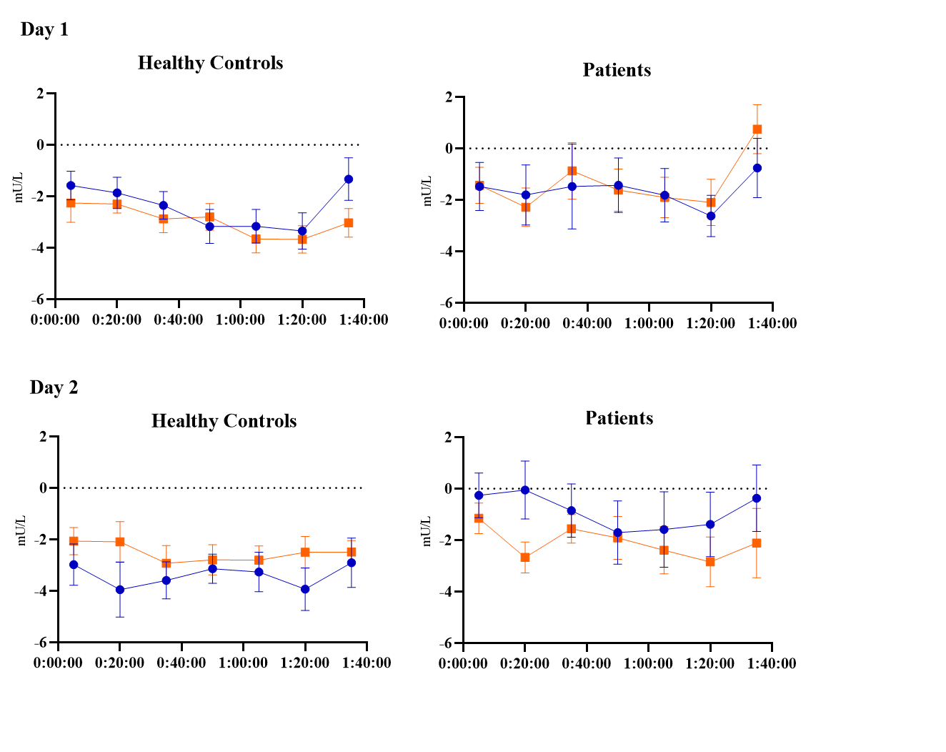

**C-peptide**

*Effects of insulin spray (Day 1).* There was a significant effect of the group-condition-time interaction on the C-Peptide levels on day 1 (B=0.01, SE=0.001, p=0.008). Patients had a significant increase in C-peptide levels during the session (B=0.01, SE=0.002, p=0.001). In healthy participants, there was a significant time-condition interaction (B=-0.01, SE=0.003, p=0.006), demonstrating a decrease in C-peptide levels in heathy participants who received insulin spray, and no change in healthy participants who received placebo (Figure 6).

The time-condition-sex interaction was significant (B=-0.04, SE=0.01, p < 0.001). There was a significant time-condition interaction in female participants (B=-0.01, SE=0.003, p < 0.001) but not in male participants (B=0.001, SE=0.004, p=0.826), indicating that the decrease found in C-peptide levels after insulin administration, was present only in females.

*Effects of conditioning with insulin (Day 2)*. There was no effect of condition (B=0.05, SE=0.05, p=0.265), group (B=0.05, SE=0.05, p=0.257) or time (B=0.001, SE=0.002, p=0.833) on the C-peptide levels on day 2. **(Figure 6,** bottom panels). There was no effect of sex on conditioned C-peptide levels (B=-0.002, SE=0.09, p=0.982), the interactions of other variables with sex were not significant (all p’s > .315).

**Figure 6.** The mean changes of C-peptide levels from baseline with standard errors.

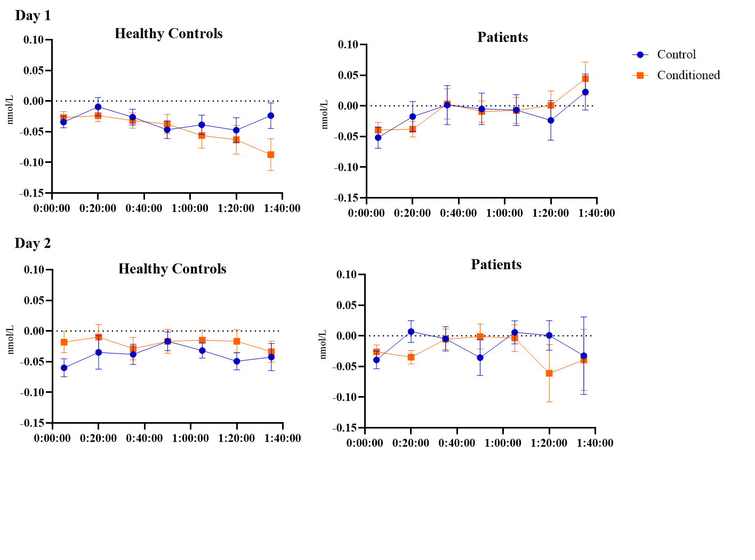

**Hunger**

*Effects of insulin spray (Day 1).* There was no effect of condition (insulin versus placebo spray) (B=-0.46, SE=0.69, p=0.504) on hunger levels on day 1. There was a significant effect of time (B=0.26, SE=0.06, p< 0.001) and group-time interaction (B=-0.25, SE=0.09, p=0.007). Hunger increased with time in healthy participants (B=0.26, SE=0.07, p < 0.001) but stayed stable in patients (B=0.01, SE=0.06, p=0.920). There was no effect of sex on hunger levels on day 1 (B=-0.48, SE=0.97, p=0.626), the interactions of other variables with sex were also not significant (all p’s > 0.107).

*Effects of conditioning with insulin (Day 2)*.There was a significant effect of time-condition- group interaction (B=0.31, SE=0.09, p < 0.001) on hunger on day 2. The time-condition interaction was significant in healthy controls (B=0.27, SE=0.06, p < 0.001) and not patients (B=0.12, SE=0.53, p=0.82) indicating that hunger increased with time in healthy controls in the control group while it stayed stable in the conditioned healthy controls (Figure 7). There was no effect of sex on hunger levels on day 2 (B=-0.48, SE=0.97, p=0.626), the interactions of other variables with sex were also not significant (all p’s > 0.069).

**Figure 7**. The mean changes of hunger from baseline with standard errors.

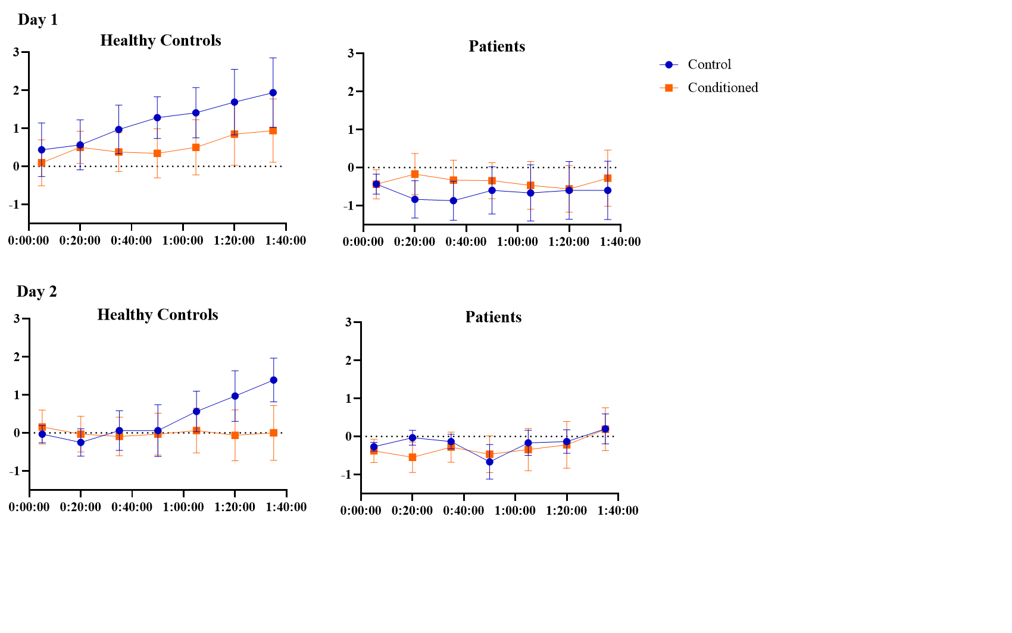**Secondary outcomes**

*Effects of insulin spray (Day 1).* There was no effect of intranasal spray administration on the food approach tendencies (reaction time: B=.01, SE=0.06, p=0.915; force: B=-0.961, SE=1.63, p=0.558), food consumption (F(3,62)=.75, p=.392), and any of the memory scores (all p’s > .171).

*Effects of conditioning (Day 2).* There was no effect of conditioning on the food approach tendencies (reaction time: B=.01, SE=0.06, p=0.915; force: B=-0.961, SE=1.63, p=0.558), food consumption (F(3,62)=1.10, p=.299), and any of the memory scores 2 (all p’s > .231) (all statistics are presented in the ESM).

**Discussion**

The aim of the current study was to investigate the effects of pharmacological conditioning with intranasal insulin on blood glucose, insulin, and c-peptide levels in patients with diabetes type-2 and healthy controls. Additionally, we studied the effects of insulin conditioning on hunger, food consumption, food approach tendencies and memory. We found that conditioning with intranasal insulin did not affect insulin or C-peptide levels, however, conditioning affected blood glucose levels in male (and not female) participants: male participants in the conditioned group had higher (i.e., more stable) glucose levels than participants in the control group on day 2. Additionally, we found that conditioning decreased hunger in healthy controls, but not in patients with diabetes type-2.

Intranasal insulin administration affected two of the three psychological outcomes of the study: it decreased C-peptide levels in healthy participants and increased (prevented from dropping) the glucose levels in patients and healthy males. At the same time only blood glucose levels were affected by conditioning, and only in male and not female participants. The direction of the effects of intranasal insulin administration on blood glucose levels on day 1 corresponded to the direction of the conditioned effects on day 2. As we had initially expected, conditioned effects mimicked the effects of the drug, however, the drug affected patients of both sexes and healthy males, while conditioning- only healthy and patient males. Importantly, the direction of the effect did not correspond to the direction found in the previous study [5] that found that both intranasal insulin and conditioning decreased glucose. The main difference between our study and the previous study by Stockhorst and colleagues is the age of participants: Stockhorst included young healthy males with a mean age of 24 years while our sample consisted of patients and age-matched healthy controls with an average age of 68 years. It is possible that the effects on intranasal insulin may vary with age and health status. Several studies found that various doses of intranasal insulin lead to a mild decrease of blood glucose levels in healthy young adults [22–24] while no such effect was found in overweight or obese patients [25] and patients with type-2 diabetes [26]. It is important to note, that all patient studies had significantly older participants, while studies on the effects of insulin in healthy individuals, included young population. There are multiple changes in energy metabolism occurring with age that are caused by both endocrine changes and changes in lifestyle [27]. Therefore, it is quite conceivable that the effects of (conditioning with) insulin on endocrine and metabolic parameters are different between distinct age groups and people with or without metabolic disease. It is also hard to say if the conditioned effect we found is beneficial or not for patients. On the one hand, diabetes treatment aims to reduce blood glucose. On the other hand though, instability of plasma glucose levels has been shown to promote microvascular and macrovascular complications such as retinopathy, nephropathy and heart disease [28, 29], and the importance of stabilizing glucose levels is widely discussed in literature [30, 31]. Future research should look into how beneficial intranasal insulin is for glucose metabolism for patients with diabetes type-2.

We have also found that conditioning with intranasal insulin decreased hunger in healthy participants, partially confirming our study hypothesis. As blood insulin levels rapidly rise after food intake and insulin penetrates the blood brain barrier, it serves as one of the signals to the central nervous system, and particularly the hypothalamus, to stop feeding and decrease hunger [32]. Intranasal insulin has been shown to affect hypothalamic neuronal activity [12]. Perhaps conditioning with intranasal insulin triggers neuronal activity in the hypothalamus that a dampens appetite. However, this effect was found only in healthy controls and not in patients with diabetes type-2. Patients in our sample did not have any increase in hunger during the sessions, even though they had significantly higher baseline hunger than healthy controls. This finding is in keeping with previous research that found that obese patients and patients with diabetes type-2 might be less responsive to the metabolic effects of intranasal insulin [25] [26].

In apparent contrast, no effects of insulin or conditioning were found on the calories consumed. The total amount of calories eaten during the bogus test was very low, possibly because participants knew that the experiment was almost over and they could have a larger meal in several minutes. For future research, we would propose a more substantial meal, for example, a lunch buffet, to measure food consumption.

The sex differences found in our study align with previous research findings of the effects of intranasal insulin. Sex differences were found in previous research on the effects of insulin on declarative and working memory [33] [34], and food intake [34], however not all studies replicated these findings [35]. The evidence on sex differentiation in intranasal insulin effects is very mixed to this point and appears to be dependent on the timing of administration and health status of participants.

No effect of intranasal insulin or insulin conditioning was found on memory. This does not align with several study findings that intranasal insulin administration improves memory in both healthy controls and patients with memory impairments [36, 37]. However, most of the studies that found memory-improving effects of intranasal insulin, investigated the effects of long-term treatment that lasted for several weeks [38–40]. In our study, we administered 120 units once, which may have been not enough to have an effect on memory of our participants. It is worthwhile to investigate whether extending the learning phase of conditioning, and administering higher doses of intranasal insulin, would lead to conditioned memory improvement.

Several limitations of our study have to be mentioned. First of all, the findings related to sex differences were done in exploratory analyses as we had no directional hypothesis regarding sex effects. However, considering sex differences found in previous research, we recruited similar numbers of males and females in each of the experimental groups. A previous experiment documenting a metabolic effect of insulin conditioning [5] studied only males, which matches our findings, showing (albeit opposite) conditioned effects on glucose levels in males only. The impact of sex on the metabolic effects of insulin conditioning needs to be confirmed in a study that is specifically powered to detect sex differences. Secondly, the male-female ratio in our study is not entirely equal: due to practical issues and the constraints the COVID-19 pandemic posed, we had to deviate slightly from an equal balance. Finally, the results found in our study are not necessarily generalizable to patients with more severe diabetes type-2. We intentionally included only patients with milder disease, who were treated either with behavioral interventions or metformin, and not patients who received insulin injections. Patients with severe insulin resistance or a significant loss of beta-cells might not be responsive to conditioning manipulations.

Our study has several important implications. We have provided further evidence that glucose responses can be classically conditioned, importantly not only in healthy controls but also in male patients with diabetes type-2. It opens possibilities for further research on conditioning of other drugs effects that are used for diabetes type-2, such as, for example, metformin. If our results are proven to be generalizable to other drug effects, classical conditioning can be applied to diabetes type-2 treatment as a part of drug reduction programs [41] or as a booster for pharmacological drug effects [42]. Moreover, we demonstrated that conditioning with intranasal insulin reduces hunger in healthy participants. Hunger can be a problem not only for patients with diabetes type-2 but for population who needs to follow a diet for other health reasons. Applying intranasal insulin conditioning can helpful for these groups of people.

Our study points at the importance of choosing an unconditioned stimulus relevant for the clinical group. Conditioning with intranasal insulin might be beneficial for the groups suffering from elevated hunger, but might not be particularly suitable for blood glucose reduction. To create optimal and safe conditioning protocols for clinical practice, we need to better understand the action mechanisms of the unconditioned stimulus chosen as well as the impact of sex and age.

**Funding**

The study was funded by the Diabetes II Breakthrough grant by Dutch Diabetes Fonds and ZonMW (project number 459001009) awarded to AWME. The work of Hilmar Zech was supported by a grant from the German Research Foundation (project number 402170461).

**Acknowledgements**

We would like to thank U. Stokhorst for the input on parts of the study protocol. We also thank Monique Smeets and Ilja Croijmans for their help with preparation of the smelling sticks. Participant recruitment was accomplished through Hersenonderzoek.nl, a Dutch online registry that facilitates participant recruitment for neuroscience studies (www.hersenonderzoek.nl). Hersenonderzoek.nl is funded by ZonMw-Memorabel (project number 73305095003), a project in the context of the Dutch Deltaplan Dementie, Gieskes-Strijbis Foundation, the Alzheimer’s Society in the Netherlands and Brain Foundation Netherlands.

**References**

1. Tekampe J, van Middendorp H, Meeuwis SH, et al (2017) Conditioning Immune and Endocrine Parameters in Humans: A Systematic Review. Psychother Psychosom 86(2):99–107. https://doi.org/10.1159/000449470

2. Skvortsova A, Veldhuijzen DS, Kloosterman IEM, et al (2019) Conditioned hormonal responses: A systematic review in animals and humans. Front Neuroendocrinol 52:206–218. https://doi.org/10.1016/j.yfrne.2018.12.005

3. Stockhorst U, Huenig A, Ziegler D, Scherbaum WA (2011) Unconditioned and conditioned effects of intravenous insulin and glucose on heart rate variability in healthy men. Physiology & behavior 103(1):31–38

4. Stockhorst U, Steingrüber H-J, Scherbaum WA (2000) Classically conditioned responses following repeated insulin and glucose administration in humans. Behavioural brain research 110(1–2):143–159

5. Stockhorst U, De Fries D, Steingrueber H-J, Scherbaum WA (2011) Unconditioned and conditioned effects of intranasally administered insulin vs placebo in healthy men: a randomised controlled trial. Diabetologia 54(6):1502–1506

6. Stockhorst U, Gritzmann E, Klopp K, et al (1999) Classical conditioning of insulin effects in healthy humans. Psychosomatic medicine 61(4):424–435

7. Detke MJ, Brandon SE, Weingarten HP, Rodin J, Wagner AR (1989) Modulation of behavioral and insulin responses by contextual stimuli paired with food. Physiology & behavior 45(4):845–851

8. Roozendaal B, Oldenburger WP, Strubbe JH, Koolhaas JM, Bohus B (1990) The central amygdala is involved in the conditioned but not in the meal-induced cephalic insulin response in the rat. Neuroscience letters 116(1–2):210–215

9. Surwit RS, McCubbin JA, Livingston EG, Feinglos MN (1985) Classically conditioned hyperglycemia in the obese mouse. Psychosomatic medicine 47(6):565–568

10. Stockhorst U, Mahl N, Krueger M, et al (2004) Classical conditioning and conditionability of insulin and glucose effects in healthy humans. Physiology & behavior 81(3):375–388

11. Born J, Lange T, Kern W, McGregor GP, Bickel U, Fehm HL (2002) Sniffing neuropeptides: a transnasal approach to the human brain. Nature neuroscience 5(6):514

12. van Opstal AM, Akintola AA, van der Elst M, et al (2017) Effects of intranasal insulin application on the hypothalamic BOLD response to glucose ingestion. Scientific reports 7(1):13327

13. Vidarsdottir S, Smeets PA, Eichelsheim DL, et al (2007) Glucose ingestion fails to inhibit hypothalamic neuronal activity in patients with type 2 diabetes. Diabetes 56(10):2547–2550

14. Hallschmid M, Higgs S, Thienel M, Ott V, Lehnert H (2012) Postprandial administration of intranasal insulin intensifies satiety and reduces intake of palatable snacks in women. Diabetes 61(4):782–789. https://doi.org/10.2337/db11-1390

15. Jauch-Chara K, Friedrich A, Rezmer M, et al (2012) Intranasal insulin suppresses food intake via enhancement of brain energy levels in humans. Diabetes 61(9):2261–2268

16. Novak V, Milberg W, Hao Y, et al (2014) Enhancement of vasoreactivity and cognition by intranasal insulin in type 2 diabetes. Diabetes care 37(3):751–759

17. Ott V, Benedict C, Schultes B, Born J, Hallschmid M (2012) Intranasal administration of insulin to the brain impacts cognitive function and peripheral metabolism. Diabetes, obesity and metabolism 14(3):214–221

18. Zech HG, Rotteveel M, van Dijk WW, van Dillen LF (2020) A mobile approach-avoidance task. Behavior Research Methods 52(5):2085–2097

19. van den Akker K, Schyns G, Jansen A (2016) Enhancing inhibitory learning to reduce overeating: Design and rationale of a cue exposure therapy trial in overweight and obese women. Contemporary clinical trials 49:85–91

20. Schakel L, Veldhuijzen DS, Middendorp H van, et al (2018) The effects of a gamified approach avoidance training and verbal suggestions on food outcomes. PloS one 13(7):e0201309

21. Lezak MD, Howieson DB, Loring DW, Fischer JS (2004) Neuropsychological assessment. Oxford University Press, USA

22. Benedict C, Brede S, Schiöth HB, et al (2011) Intranasal insulin enhances postprandial thermogenesis and lowers postprandial serum insulin levels in healthy men. Diabetes 60(1):114–118

23. Leary AC, Stote RM, Breedt HJ, O’brien J, Buckley B (2005) Pharmacokinetics and pharmacodynamics of intranasal insulin administered to healthy subjects in escalating doses. Diabetes technology & therapeutics 7(1):124–130

24. Dash S, Xiao C, Morgantini C, Koulajian K, Lewis GF (2015) Intranasal insulin suppresses endogenous glucose production in humans compared with placebo in the presence of similar venous insulin concentrations. Diabetes 64(3):766–774

25. Xiao C, Dash S, Stahel P, Lewis GF (2018) Effects of intranasal insulin on endogenous glucose production in insulin-resistant men. Diabetes, Obesity and Metabolism 20(7):1751–1754

26. Gancheva S, Koliaki C, Bierwagen A, et al (2015) Effects of intranasal insulin on hepatic fat accumulation and energy metabolism in humans. Diabetes 64(6):1966–1975

27. Roberts SB, Rosenberg I (2006) Nutrition and aging: changes in the regulation of energy metabolism with aging. Physiological reviews 86(2):651–667

28. Control D, Group CTR (1995) The relationship of glycemic exposure (HbA1c) to the risk of development and progression of retinopathy in the diabetes control and complications trial. Diabetes 44(8):968–983

29. Klein R (1995) Hyperglycemia and microvascular and macrovascular disease in diabetes. Diabetes Care 18(2):258–268. https://doi.org/10.2337/diacare.18.2.258

30. Monnier L, Colette C (2008) Glycemic variability: should we and can we prevent it? Diabetes care 31(Supplement 2):S150–S154

31. Gómez AM, Muñoz OM, Marin A, et al (2018) Different indexes of glycemic variability as identifiers of patients with risk of hypoglycemia in type 2 diabetes mellitus. Journal of diabetes science and technology 12(5):1007–1015

32. Hallschmid M, Schultes B, Marshall L, et al (2004) Transcortical direct current potential shift reflects immediate signaling of systemic insulin to the human brain. Diabetes 53(9):2202–2208

33. Benedict C, Hallschmid M, Schultes B, Born J, Kern W (2007) Intranasal insulin to improve memory function in humans. Neuroendocrinology 86(2):136–142

34. Claxton A, Baker LD, Wilkinson CW, et al (2013) Sex and ApoE genotype differences in treatment response to two doses of intranasal insulin in adults with mild cognitive impairment or Alzheimer’s disease. Journal of Alzheimer’s Disease 35(4):789–797

35. Santiago JC, Hallschmid M (2017) Central nervous insulin administration before nocturnal sleep decreases breakfast intake in healthy young and elderly subjects. Frontiers in neuroscience 11:54

36. Hallschmid M (2021) Intranasal insulin. Journal of Neuroendocrinology 33(4):e12934

37. Benedict C, Frey II WH, Schiöth HB, Schultes B, Born J, Hallschmid M (2011) Intranasal insulin as a therapeutic option in the treatment of cognitive impairments. Experimental gerontology 46(2–3):112–115

38. Benedict C, Hallschmid M, Schmitz K, et al (2007) Intranasal insulin improves memory in humans: superiority of insulin aspart. Neuropsychopharmacology 32(1):239–243

39. Benedict C, Hallschmid M, Hatke A, et al (2004) Intranasal insulin improves memory in humans. Psychoneuroendocrinology 29(10):1326–1334

40. Hallschmid M, Benedict C, Schultes B, Born J, Kern W (2008) Obese men respond to cognitive but not to catabolic brain insulin signaling. International journal of obesity 32(2):275–282

41. Doering BK, Rief W (2012) Utilizing placebo mechanisms for dose reduction in pharmacotherapy. Trends in pharmacological sciences 33(3):165–172

42. Kirchhof J, Petrakova L, Brinkhoff A, et al (2018) Learned immunosuppressive placebo responses in renal transplant patients. Proc Natl Acad Sci USA 115(16):4223–4227. https://doi.org/10.1073/pnas.1720548115